**Prostate Lesion Scoring**

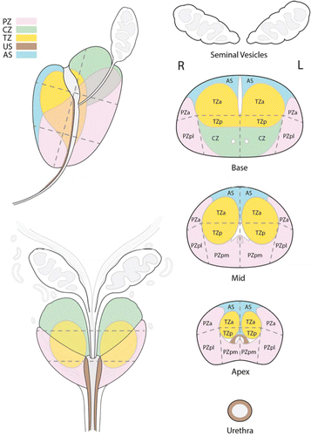

**SIZE: XX mm**

**T2 Scoring PZ T2 Scoring TZ**

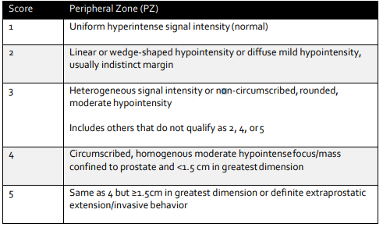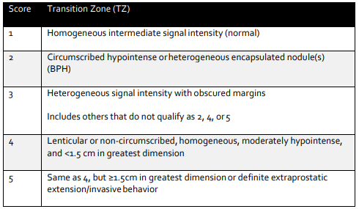

**Diffusion**

Insufficient

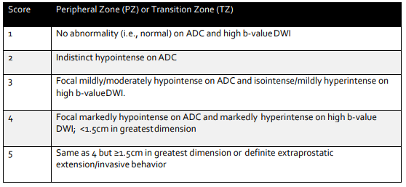

**DCE:**

Insufficient

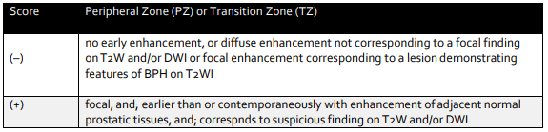**______________________________________________________________________________________**

**EPE grade: Capsular bulging? At least 1.5 cm contact along the capsule? Clear Extension?**